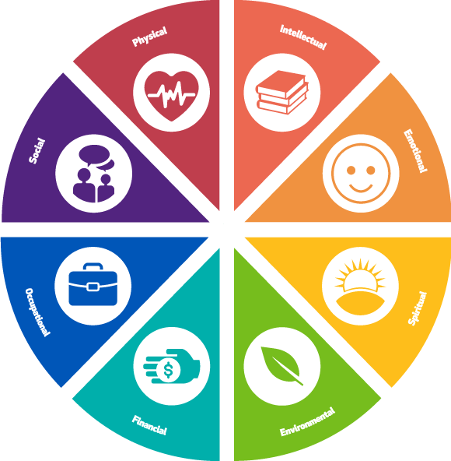**Well-Being Assessment**

This self-assessment is designed to have you reflect on your personal level of satisfaction looking at various dimensions of well-being. This is not about comparing yourself to others, or where you think you should be in life. It is about reflecting on your own personal level of satisfaction you want in each area and asking yourself honestly on a scale of 1 – 10 how satisfied are you? Your honest answer to this question will give you access to knowing which area to focus on.

|  |  |  |  |  |  |  |  |  |  |  |
| --- | --- | --- | --- | --- | --- | --- | --- | --- | --- | --- |
| **Area of Well-Being** | **1** | **2** | **3** | **4** | **5** | **6** | **7** | **8** | **9** | **10** |
| **Emotional**—Coping effectively with life and creating satisfying relationships |  |  |  |  |  |  |  |  |  |  |
| **Environmental**—Good health by occupying pleasant, stimulating environments that support well-being |  |  |  |  |  |  |  |  |  |  |
| **Financial**—Satisfaction with current and future financial situations |  |  |  |  |  |  |  |  |  |  |
| **Intellectual**—Recognizing creative abilities and finding ways to expand knowledge and skills |  |  |  |  |  |  |  |  |  |  |
| **Occupational**—Personal satisfaction and enrichment from one’s work |  |  |  |  |  |  |  |  |  |  |
| **Physical**—Recognizing the need for physical activity, healthy foods and sleep |  |  |  |  |  |  |  |  |  |  |
| **Social**—Developing a sense of connection, belonging and a well-developed support system |  |  |  |  |  |  |  |  |  |  |
| **Spiritual**—Expanding a sense of purpose and meaning in life |  |  |  |  |  |  |  |  |  |  |